# Caremark.com Log in and Registration (Carrier to Carrier) Enhancements

View my plans Feature for Members on the Caremark.com Dashboard

Logging in with Deactivated Username and Password to Access an Inactive Account

Edit/Change Username

All Prescriptions – Multiple Active Plans

Related Documents

**Description:** This document covers the **View my plans** feature from the Caremark.com dashboard that allows members to access and view current, upcoming, and past plans using the same username and password.

|  |
| --- |
| View my plans Feature for Members on the Caremark.com Dashboard |

Members who have or have had more than one plan with CVS Caremark in the past 36 months based on termination date have a new feature displayed on the dashboard titled “**View my plans”**. This allows members to access any of their plans by just clicking on the link, selecting the plan they want to access, and sign in with the same username and password.

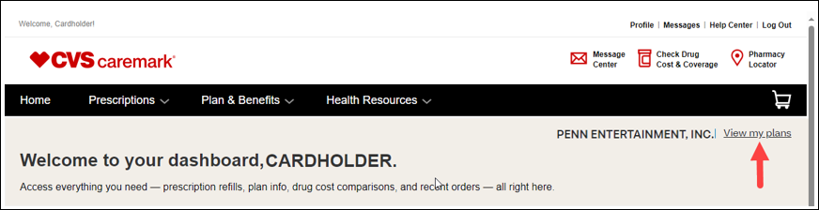

**Troubleshooting:**

Ask the member which plan they currently see listed next to “View my plans” to ensure they are signed into their active plan. When members first sign in, it should default to their active plan.

 **Note:** If the member has more than one plan (i.e., primary/secondary plan), the member will be signed in under the carrier with the latest or most recent effective date as the default plan. If not the plan the member wants to be signed into, ask the member to click on the “View My Plans” link located on the Dashboard to sign into their primary plan.

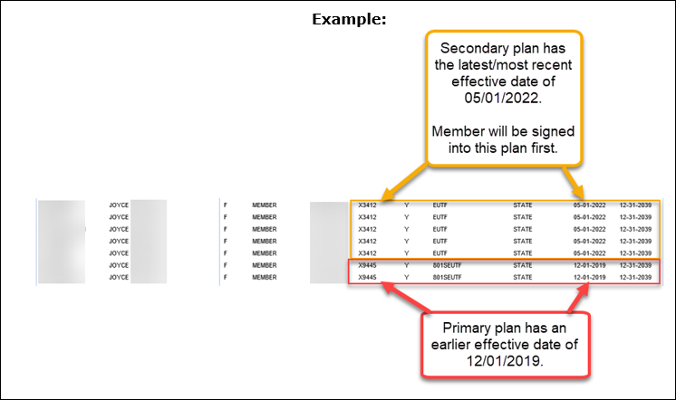

If the member states they are not seeing the “View My Plans” link on the dashboard, ask the member to perform the following (Note: This should result in the link to be viewable):



1. Log out of their web account.
2. Check to confirm the browser they are using is the latest version and clear the cache.
3. Log back into their web account and look for the “View My Plans” link on the right side of the Dashboard.

**IF member signs in and their account is inactive or not their current plan:**

Ask the member to click “**View my plans”.**

Members will see **current**, **upcoming**, and **past plans** in the last 36 months based on the termination date. If the member wants to access or view another plan, they simply select the plan and sign in again using the same username and password.

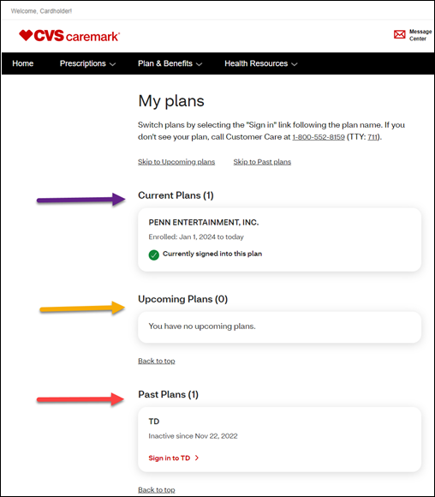

**Note:** You should no longer need to delete a member’s registration from an inactive account to allow the member to access their active account. Members can simply select and sign into any of their accounts using the same username and password.

* When a member has selected another plan to view and has signed in using the same username and password, they can always go back to “View my plans” from the Dashboard, select their active default plan, and sign in again using the same username and password.
* If the member signs out of Caremark.com and signs in again later, they will be signed into their default plan.

 Customer Service Representatives can view this page but **will not** be able to utilize the sign in/sign out functionality. It will be necessary that the Customer Service Representative close out of the PeopleSafe profile they are in and access a different profile for the member (active or inactive), if needed.

Top of the Document

|  |
| --- |
| Logging in with Deactivated Username and Password to Access an Inactive Account |

When a member attempts to sign into an account that has been deactivated, the following message will appear:

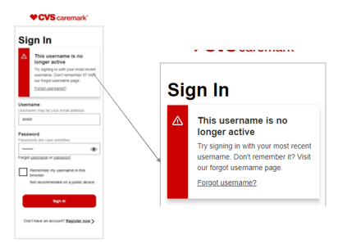

Advise the member to try signing in with their most recent username.

* If the member is unable to recall their username, they can click the **Forgot username** link or Customer Care can assist the member with verifying the member’s username, associated with their current plan. Refer to [Caremark.com – Update Profile](https://thesource.cvshealth.com/nuxeo/thesource/#!/view?docid=90c8be08-51d0-4c28-ac12-010337674133).

 For users who only have one username, there will be no impact.

Top of the Document

|  |
| --- |
| Edit/Change Username |

Members will have the ability to edit or change their username by clicking the **Profile** link. When clicking on the **Profile** link, members are taken directly to the **Profile** page.

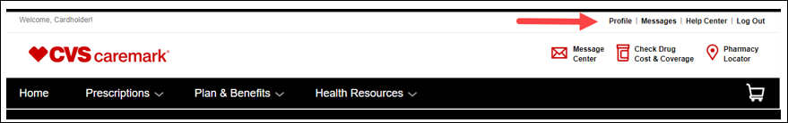

* Click **Edit Username**

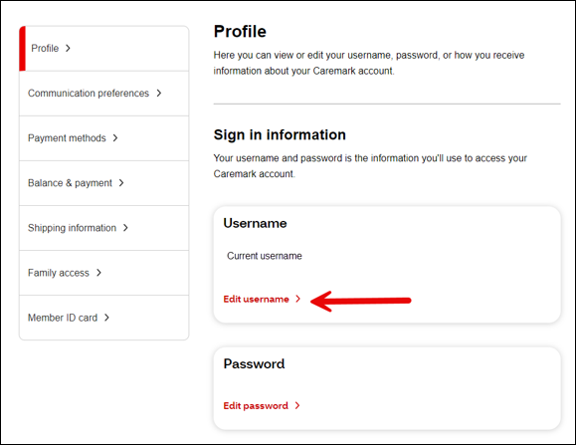

* **Enter new username** and click **Save and sign out. (Note:** When the member clicks **Save and sign out,** they will be signed out and will need to sign in again with their **new username)**

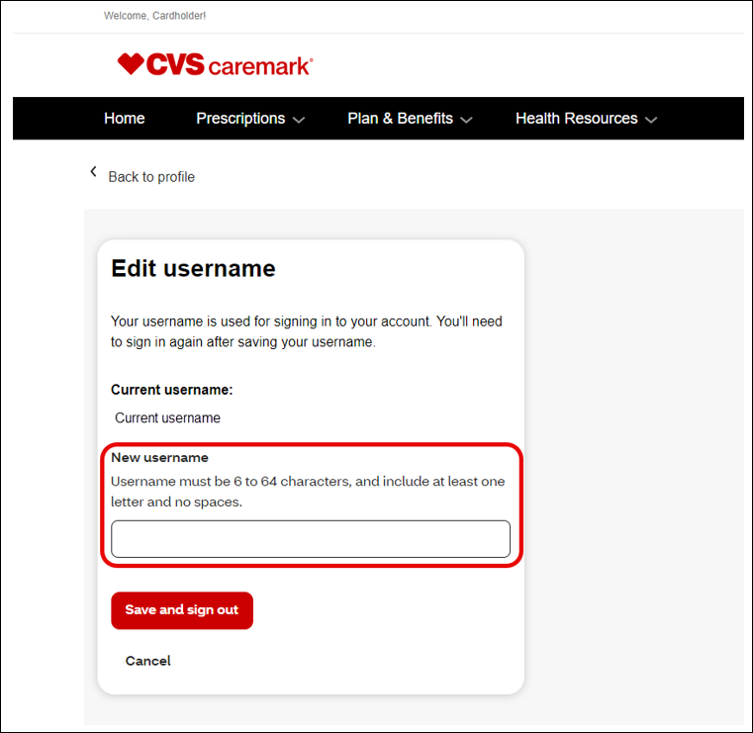

When successfully updating the username, the following messaging will display:

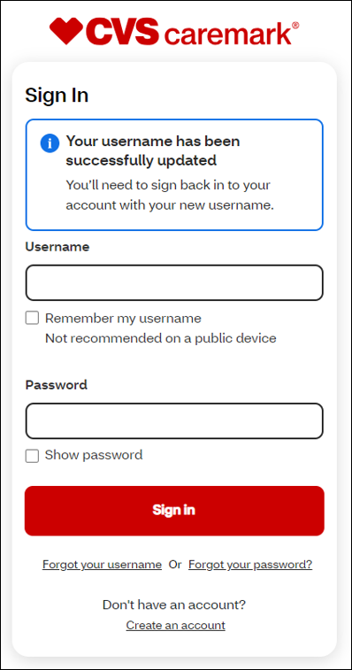

Top of the Document

|  |
| --- |
| All Prescriptions – Multiple Active Plans |

The active prescriptions will display on the **All Prescriptions** page with a message to contact Customer Care if the prescriptions have not been transferred to the member’s current plan. Active prescriptions can be transferred using the automated process in PeopleSafe/Compass.

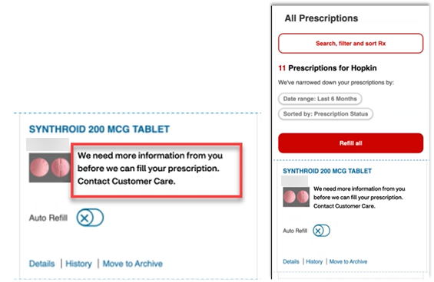

Top of the Document

|  |
| --- |
| Related Documents |

[Caremark.com and Mobile Web – New Log In/Multifactor Authentication (MFA)](https://thesource.cvshealth.com/nuxeo/thesource/#!/view?docid=fb037e34-deba-4d00-af22-d401e0394aab)

[Caremark.com – “New” Registration Flow Rewrite](https://thesource.cvshealth.com/nuxeo/thesource/#!/view?docid=2922d262-0374-4a26-820b-0a5ffe1085bd)

Not to Be Reproduced or Disclosed to Others without Prior Written Approval

**ELECTRONIC DATA = OFFICIAL VERSION / PAPER COPY = INFORMATIONAL ONLY**